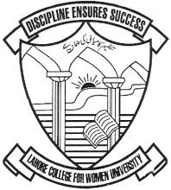
JOURNAL OF ARTS AND SOCIAL SCIENCES
JASS
Faculty of Humanities and Social Sciences
Lahore College for Women University
Jail Road, Lahore – Pakistan. Tel: 042-99203801- 05 Ext 272
Consent
Title |  |  | 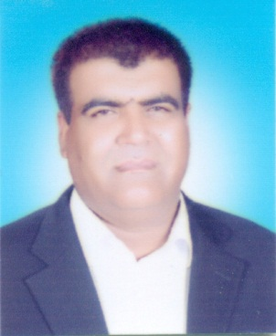  (Click the above icon to select picture)
Name | Dr. Muhammad Idris
Designation | Assistant Professor
Affiliation | Abdul Wali Khan University Mardan
Correspondence  Address | Assistant Professor, Department of Education, Abdul Wali Khan University Mardan
Gender | - Male
Country of Citizenship | Pakistan | Country of residence | Mardan
Contact No | +923038555588 / +923319219952
Primary Email | midrees@awkum.edu.pk
Alternate Email | midrees@awkum.edu.pk
Area(s) of Interest  (Use Semi-colon as separator) | Conflict Resolution, Peace Education, Education Management, Curriculum
I hereby declare that all the facts described by me is true, correct and best of my knowledge.
I Dr. Muhammad Idris do hereby give my consent for Journal of Art and Social Sciences (JASS) to include me as a member of International Advisory Board/Editorial Board.
Date | Signature and Official Seal
16-12-2019 | 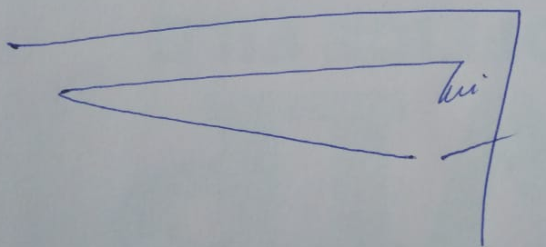

Documents required:
- Curriculum Vitae along
- Recent Passport Size Picture

